**Advance Excel Assignment –7**

**By Abhishek Sachan**

**1. Using Insert Function, give examples of any function available in the different dropdowns are present in the function library. For example, AutoSum, Recently Used, Text, Date & Time, etc.**

* AutoSum: This function is used to quickly sum a range of cells in Excel. To use this function, select the cell where you want the sum to appear, click on the "AutoSum" dropdown in the "Formulas" tab, and select "Sum."
* Recently Used: This dropdown shows the functions that you have recently used, making it easy to access them quickly.
* Text: This dropdown contains functions that are used to manipulate text in Excel. For example, the "LEFT" function returns a specified number of characters from the left side of a text string.
* Date & Time: This dropdown contains functions that are used to work with dates and times in Excel. For example, the "NOW" function returns the current date and time.
* Financial: This dropdown contains functions that are used for financial calculations in Excel. For example, the "PV" function calculates the present value of an investment based on a series of future payments.
* Logical: This dropdown contains functions that are used to evaluate logical expressions in Excel. For example, the "IF" function returns one value if a condition is true and another value if it is false.
* Math & Trig: This dropdown contains functions that are used for mathematical and trigonometric calculations in Excel. For example, the "SIN" function returns the sine of an angle.
* Lookup & Reference: This dropdown contains functions that are used to look up values in a table or range in Excel. For example, the "VLOOKUP" function looks up a value in the first column of a table and returns a corresponding value from a specified column.
* Database: This dropdown contains functions that are used to work with databases in Excel. For example, the "DSUM" function calculates the sum of values in a database that meet specified criteria

**2. What are the different ways you can select columns and rows?**

* **Selecting a single column or row:** To select a single column or row, click on the column letter or row number. For example, to select column C, click on the "C" at the top of the column. To select row 5, click on the "5" on the left side of the row.
* **Selecting multiple columns or rows**: To select multiple columns or rows, click and drag over the column letters or row numbers. For example, to select columns A, B, and C, click on the "A" at the top of column A, hold down the left mouse button, and drag over to column C. To select rows 1, 2, and 3, click on the "1" on the left side of row 1, hold down the left mouse button, and drag down to row 3.
* **Selecting adjacent columns or rows**: To select adjacent columns or rows, click on the first column letter or row number, hold down the Shift key, and click on the last column letter or row number. For example, to select columns D, E, and F, click on the "D" at the top of column D, hold down the Shift key, and click on the "F" at the top of column F. To select rows 4, 5, and 6, click on the "4" on the left side of row 4, hold down the Shift key, and click on the "6" on the left side of row 6.
* **Selecting non-adjacent columns or rows**: To select non-adjacent columns or rows, click on the first column letter or row number, hold down the Ctrl key, and click on each additional column letter or row number that you want to select. For example, to select columns A, C, and E, click on the "A" at the top of column A, hold down the Ctrl key, and click on the "C" at the top of column C, and then click on the "E" at the top of column E. To select rows 1, 3, and 5, click on the "1" on the left side of row 1, hold down the Ctrl key, and click on the "3" on the left side of row 3, and then click on the "5" on the left side of row 5.

**3. What is AutoFit and why do we use it?**

AutoFit is a feature in Microsoft Excel that automatically adjusts the width of a column or the height of a row to fit the contents of the cells. When you use the AutoFit feature, Excel analyzes the contents of the cells in the selected column or row and adjusts the width or height accordingly.

We use AutoFit to make sure that the contents of the cells in a column or row are fully visible and not cut off or truncated. When you have a large amount of data in a cell, it may not be fully visible in the cell, and you may have to scroll to see all of it. By using AutoFit, you can make sure that all of the data is visible without having to manually adjust the column or row width or height.

**4. How can you insert new rows and columns into the existing table?**

insert multiple rows or columns, you can select the appropriate number of rows or columns before clicking the "Insert" command. Excel will insert the new rows or columns in the selected range, shifting the existing rows or columns accordingly.

"Insert Options" button that appears after you insert a new row or column to choose how to format the inserted row or column. This button appears as a small icon near the upper-left corner of the inserted row or column.

**5. How do you hide and unhide columns in excel?**

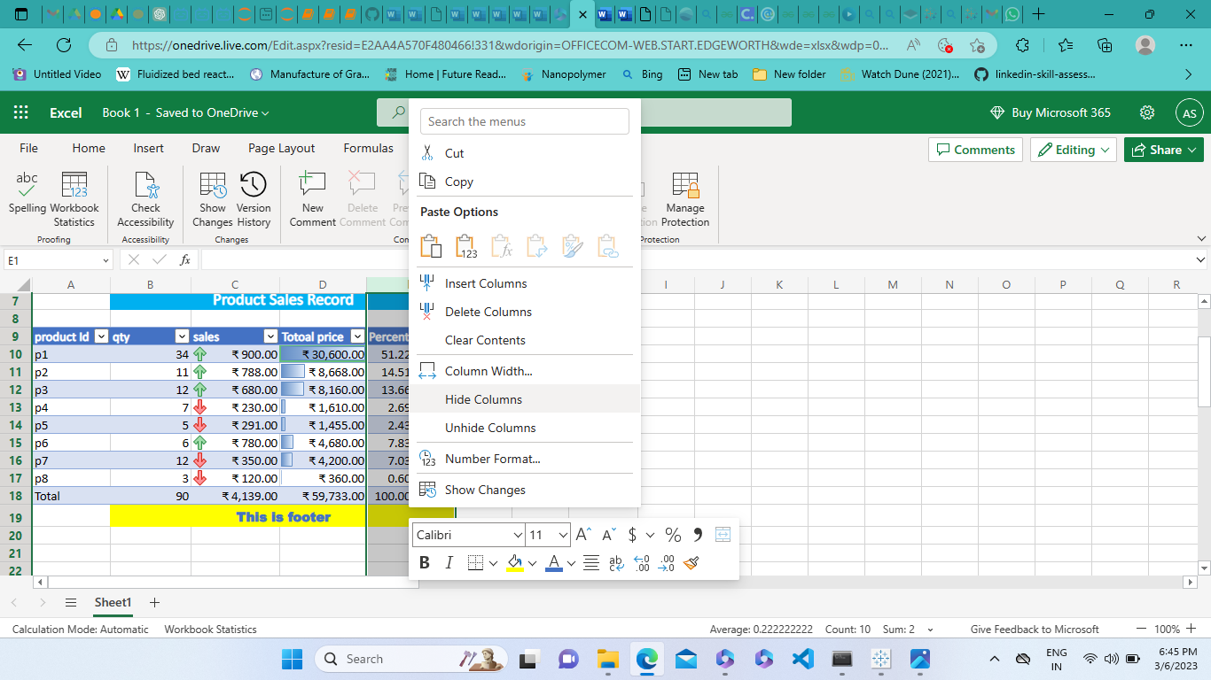

**6. Create an appropriate table within the worksheet and use different functions available in the AutoSum command.**

